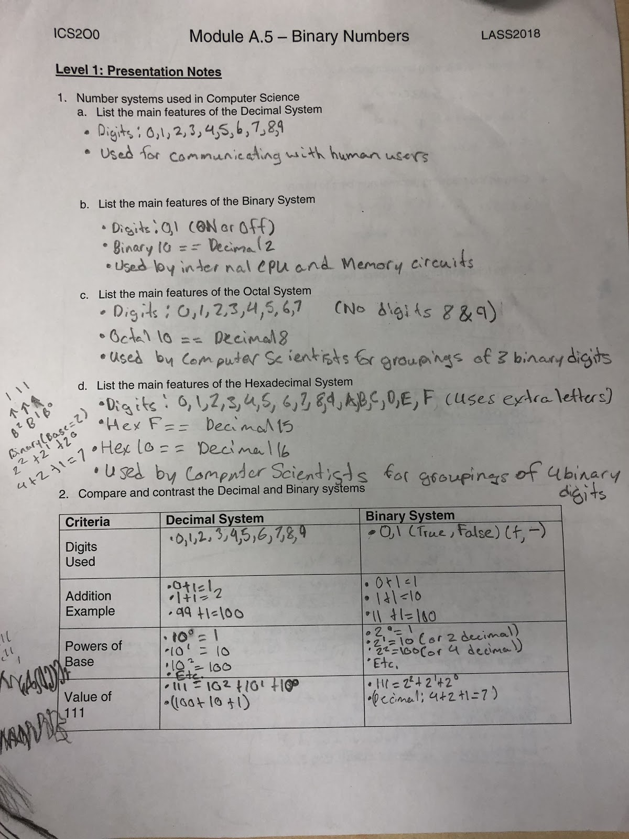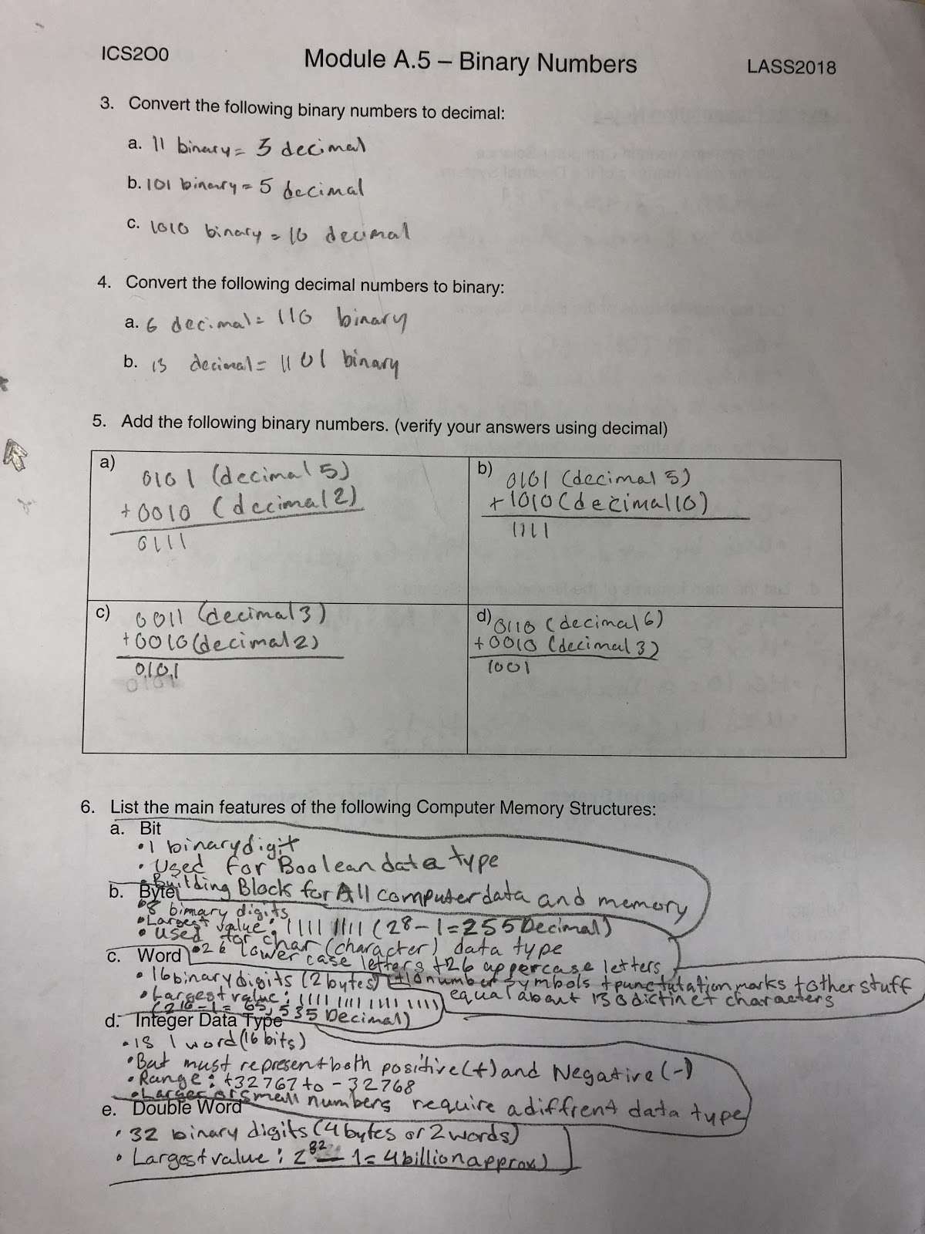

**Level 2: Research Questions**

1. The Intel 8085 microprocessor was a first generation processor that was used in many early game systems and personal computers. Google “8085 microprocessor architecture” to answer these questions.
   1. Year Introduced

1976

* 1. Size of data bus (in bits)

[8-bit](https://en.wikipedia.org/wiki/8-bit)

* 1. Largest data number (in binary and decimal)

255 Bit

* 1. Size of address bus (in bits)

20 Bit

* 1. Largest memory address (in binary and decimal)

65535 Bit

1. The Intel 8086 microprocessor was the processor used in the first IBM PCs running the DOS operating system. Google “8086 microprocessor architecture” to answer these questions.
   1. Year Introduced
   2. Size of data bus (in bits)

16-bit data bus Largest data number (in decimal)

* 1. Largest data number (in binary and decimal)

65535 Bit

* 1. Size of address bus (in bits)

20-bit address bus

* 1. Largest memory address (in decimal)

1048575 Bit

1. The Intel 80286 microprocessor a common processor used in IBM PCs running the Windows operating system. Google “80286 microprocessor architecture” to answer these questions.
   1. Year Introduced

 1982

* 1. Size of data bus (in bits)
  2. Largest data number (in decimal)

16 bit

* 1. Size of address bus (in bits)

24-bit address bus

* 1. Largest memory address (in decimal)

1. The modern PCs run either a 32 bit or 64 bit Windows operating system. Google “32 vs 64 bit” to answer these questions.
   1. How do these systems differ in data capacity? (explain using bits)
   2. How do these systems differ in memory capacity? (explain using bits)
   3. How do these systems differ in hardware requirements?
2. Research and explain how negative (-) numbers are represented using bits and how they are stored in computer memory.
3. Research and explain how floating point (decimal) numbers are represented using bits and how they are stored in computer memory.

**Level 3: Sample Program**

1. Modify the following sample Python program to print out the digits in:
   1. Binary
   2. Octal
   3. Hexadecimal

number = input("Enter a 4 digit decimal number:")

index = 0

for char in number :

index += 1

print("Digit ", index, " is : ", char)